**INTRODUCTION**

The advancement in hardware, software, and communication technologies has facilitated the emergence of Internet-connected devices that provides data from the real world. The number of devices grows and technologies become large, the volume of data in internet also high. The technology of Internet-connected devices, referred to as [Internet of Things](https://www.sciencedirect.com/topics/engineering/internet-of-things) (IoT), continues to extend the current Internet by providing connectivity and interactions between the physical and internet worlds. In addition to an increased volume, the [IoT](https://www.sciencedirect.com/topics/engineering/iot" \o "Learn more about IoT from ScienceDirect's AI-generated Topic Pages) generates big data characterized by its velocity in terms of time and location dependency, with a variety of multiple modalities and varying data quality. Intelligent processing and analysis of this big data are the key to developing smart IoT applications. The various [machine learning methods](https://www.sciencedirect.com/topics/engineering/machine-learning-method) that deal with the challenges presented by IoT data by considering smart prediction of rainfall as the main use case. The key contribution of this study is the presentation of [machine learning algorithms](https://www.sciencedirect.com/topics/engineering/machine-learning-algorithm) explaining how different techniques are applied to the data in order to extract higher level information.

**THEORITICAL ANALYSIS**

In this Project, the rainfall is predicted by using various parameters like wind, temperature and humidity. Sensor data model built using IBM IoT Platform and the generated data is given as input to the Auto AI implementation model. Auto AI implementation is trained using the data sets. Develep web app using Node-RED .Any change in the sensor data is depicted IBM IoT and the same reflected in Web App. The predicted rainfall values displayed using sensed data.

**Services Used:**

* IBM Watson Studio
* IBM Watson Machine Learning
* Node-RED
* IBM Cloud Object Storage
* IBM IoT Platform

In IBM Watson Studio we have to follow these steps Open watson studio ,Create a project, add Auto AI experiment ,create a machine learning instance ,associate ML to project ,Load the dataset to Cloud object storage, Select the prediction parameter in the dataset ,Train the model ,Deploy and Build web application using Node-red.

The various AI algorithm used are Decision Tree Classifier, Extra Trees Classifier, LGBM Classifier, Logistic Regression, Random Forest Classifier and XGB Classifier.

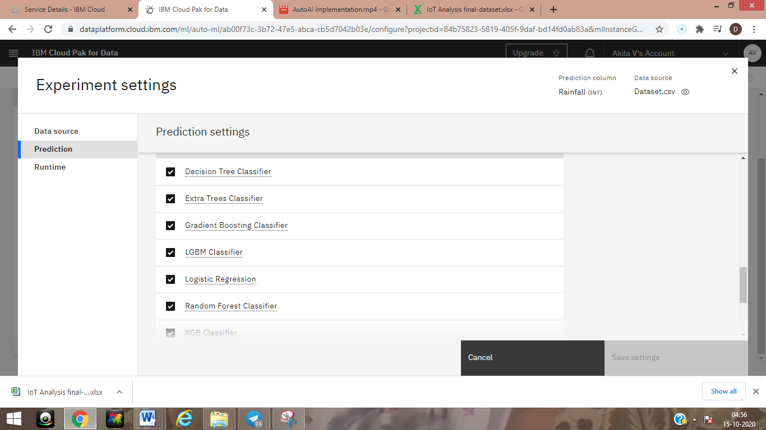

The Binary Classifier is used to predict the output because the output is 0 or 1.

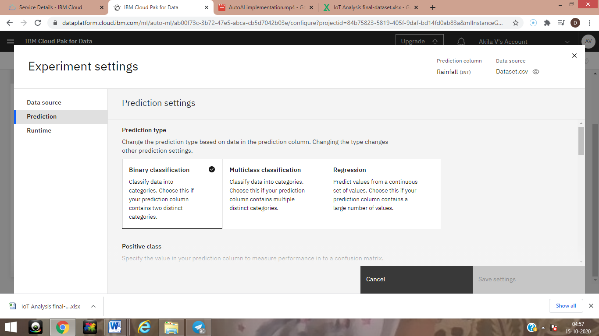

The below figure shows the running of various AI Algorithm to predict the rainfall

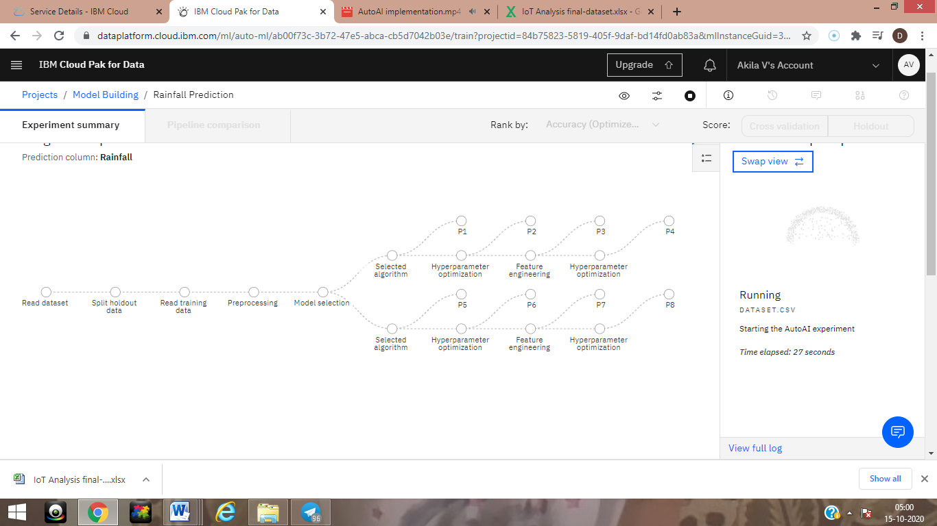

The below figure shows the training of data using pipeline operations.

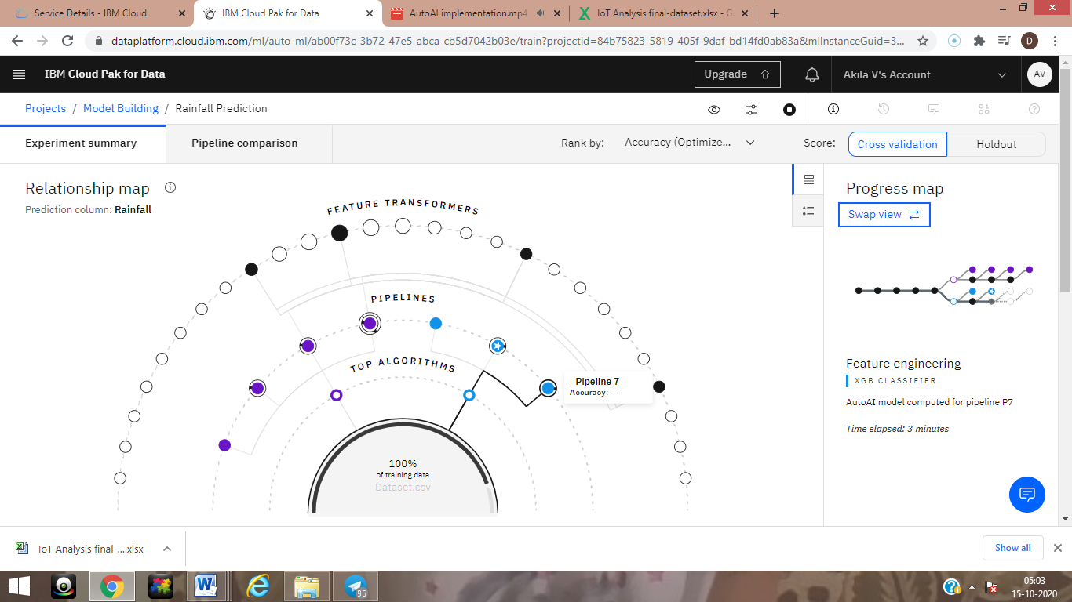

The XGB classifier shows the better result compare to other algorithms.

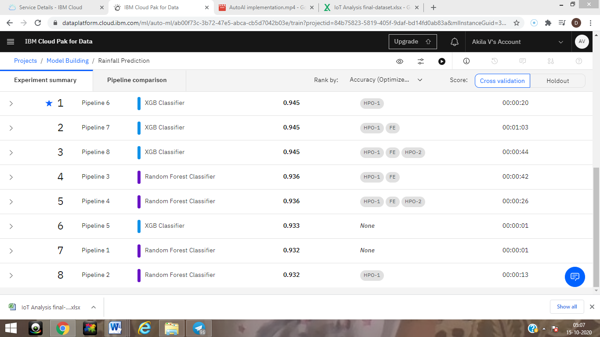

The below figure shows the devices used in IBM IoT

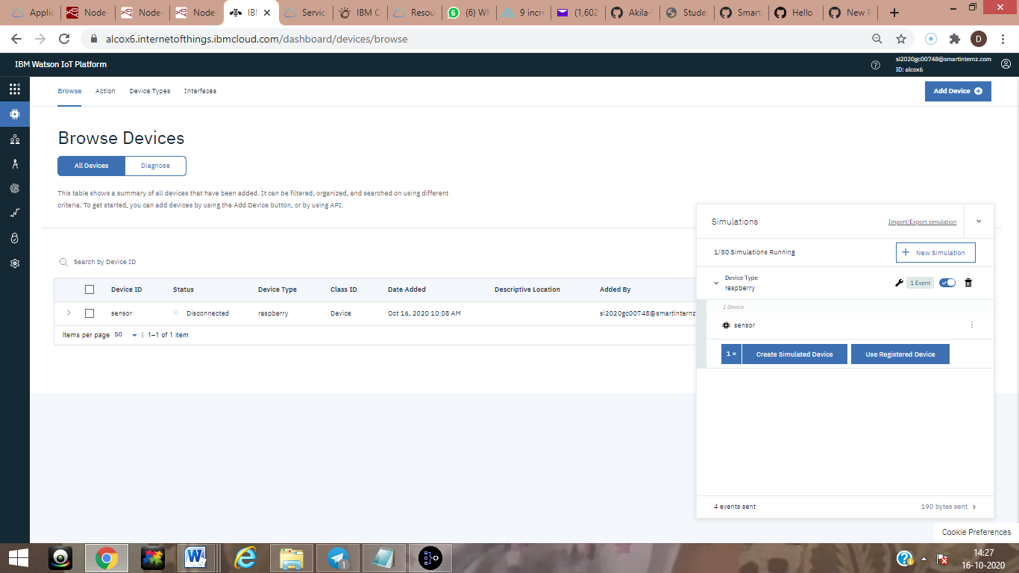

The below figure shows the parameters used in that device

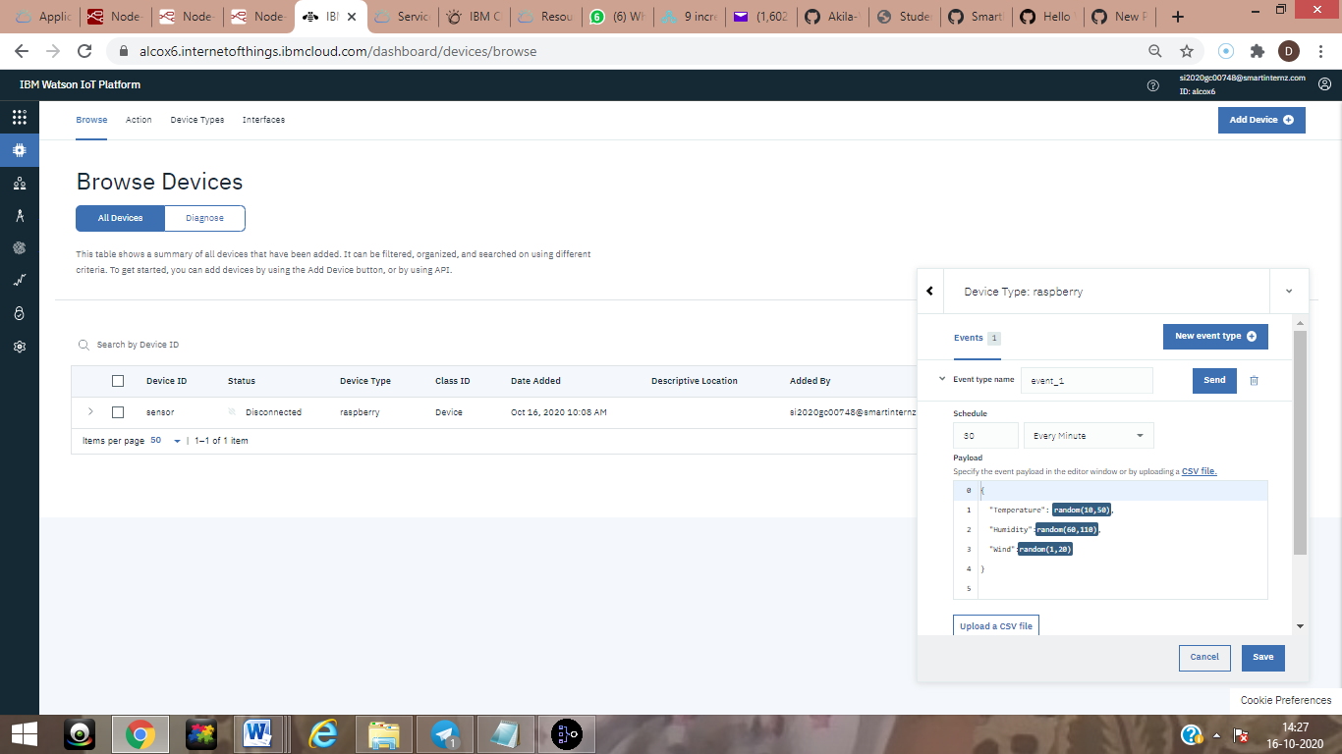

The Node Red Diagram shown below

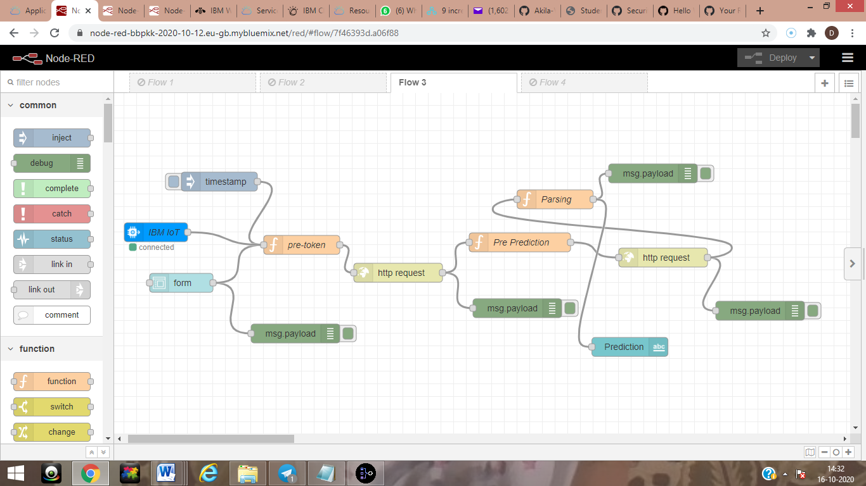

This shows the final output of rainfall prediction

